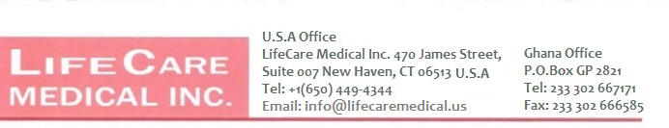

Date: {{dateMonth}} {{dateDay}}, {{dateYear}}

Identification No.: {{sqNumber}}

To: {{hospitalName}}

{{hospitalAddress}}

WHEREAS

We, LIFECARE MEDICAL INCORPORATED
who are established and reputable manufacturers of

Diagnostic Equipment, Therapeutic Equipment, Monitoring Equipment, Life Support Equipment, Surgical Instruments, Medical Furniture and Fixtures and
having factories at 30 N Gould Street STE 28185, Sheridan, WY 82801.

do hereby

- Authorize LOVEREALM LIMITED to submit a Tender in response to the Invitation for Tenders indicated above.


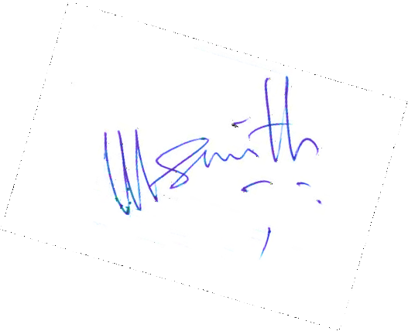
- Extend our full guarantee and warranty in accordance with Clause 15 of the General Conditions of Contract, with respect to the goods offered in the Tender.

Signed In the Capacity of Vice President Name: LIFECARE MEDICAL INCORPORATED
Duly authorized to sign the authorization for and on behalf of LIFECARE MEDICAL INCORPORATED

Dated on the {{dateDay}}{{daySuffix}} day of {{dateMonth}}, {{dateYear}}.

